Hi,  
Here's the link for the Portfolio Project

<https://exsm--3928--portfolio-mdshaha1.glitch.me/>

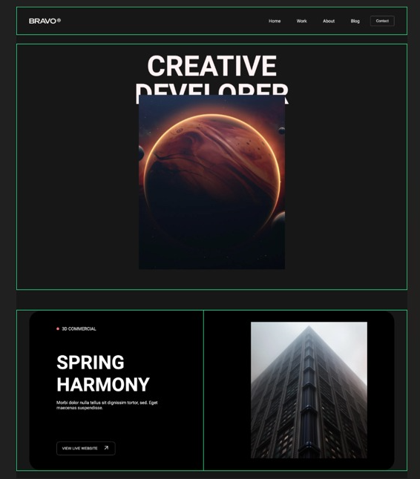



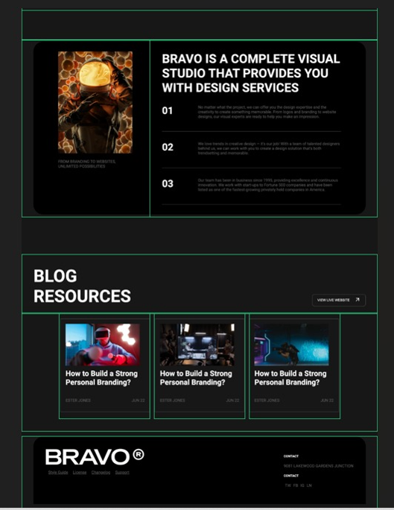

Cognizance of HTML, CSS, and JavaScript code has a precious design process, especially in researching patterns. it's veridical that as a designer we’ve to work very proximately with developers to understand the congruous functionality. HTML, CSS, and JavaScript are the building blocks of proximately every website you've visited, and they are crucial to understanding how websites are built. While these three front-end languages are all used to design websites, they each have their own categorical uses and intricacies. For example, the main distinction between HTML and CSS is that HTML engenders the document structure of a webpage while CSS embellishes the webpage by integrating formatting and style. JavaScript, controvertibly the most involute of the three, is utilized to make websites more interactive and enables the development of more intricate sites — pop-up boxes, buttons that change colors, and all the other dynamic aspects of your favorite websites are likely enabled by JavaScript.